

Name___________________________________. Mark=

|  |  |  |
| --- | --- | --- |
| Test part | Possible mark | Your mark |
| Multiple choice | 20 |  |
| Short answer | 22 |  |
| Total | 44 |  |

HUMAN BIOLOGICAL SCIENCE. YEAR 12. 2015.

Genes, evolution and Allele Frequency Topic Test.

***Multiple choice answer sheet.***

**Use a ball point or ink pen to mark an X** on the letter that represents the best answer from the choice of answers . Marks are not deducted for wrong answers.

|  |  |  |  |
| --- | --- | --- | --- |
| Question | Answer | Question |  |
| 1 | A B C D | 11 | A B C D |
| 2 | A B C D | 12 | A B C D |
| 3 | A B C D | 13 | A B C D |
| 4 | A B C D | 14 | A B C D |
| 5 | A B C D | 15 | A B C D |
| 6 | A B C D | 16 | A B C D |
| 7 | A B C D | 17 | A B C D |
| 8 | A B C D | 18 | A B C D |
| 9 | A B C D | 19 | A B C D |
| 10 | A B C D | 20 | A B C D |

Multiple choice Questions.

Use the diagram below to answer question 1.

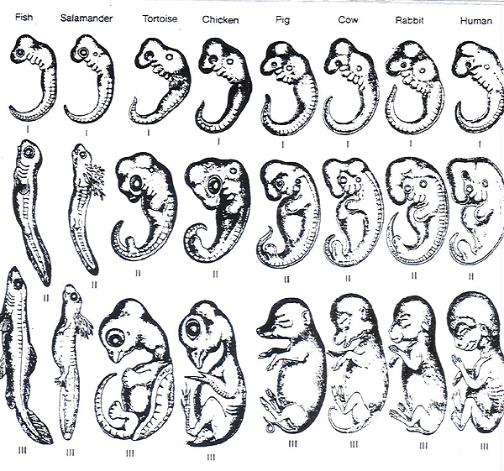

1. The diagram above shows a method of comparing different organism. What is the most accurate name and purpose of this method?
2. Comparative anatomy to show a common shared ancestor.
3. Comparative embryology to show a common shared ancestor.
4. Comparative anatomy to show natural selection.
5. Comparative embryology to show natural selection.
6. In fruit flies with the curly wing mutation, the wings will be straight if the flies are kept at 16 degrees Celsius. The most probable explanation for this is that
7. fruit flies with curly wings cannot survive at high temperatures
8. the environment influences wing phenotype in these fruit flies
9. height temperatures increases the rate of mutations
10. wing length in these fruit flies is directly proportional to temperature

|  |  |  |
| --- | --- | --- |
|  |  |  |
|  |  |  |

1. The concept that new varieties of organisms are still evolving is best supported by the:
2. Increasing need for new antibiotics.
3. Increasing numbers of individuals in the human population.
4. Decreasing number of new fossils discovered in undisturbed rock layers.
5. Decreasing activity of photosynthetic organisms due to warming of the atmosphere.
6. Mutations can be considered as one of the raw materials of evolution because they:

|  |  |  |
| --- | --- | --- |
|  | a. | contribute to new variations in organisms |
|  | b. | are usually related to the environment in which they appear |
|  | c. | are usually beneficial to the organism in which they appear |
|  | d. | usually cause species of organisms to become extinct |

1. The diagram below illustrates the change that occurred in the frequency of phenotypes in an insect population over 10 generations. A probable explanation for this change would be that over time there was:

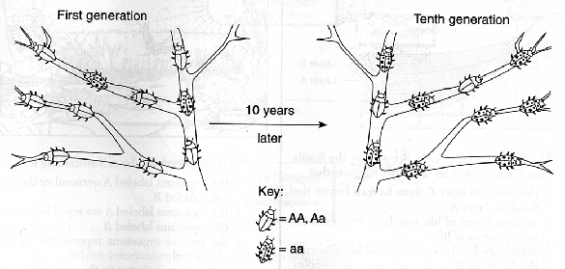

|  |  |  |
| --- | --- | --- |
|  | a. | a decrease in the adaptive(selective) value of gene a |
|  | b. | an increase in the adaptive (selective)value of gene a |
|  | c. | an increase in the population of this insect |
|  | d. | a decrease in the mutation rate of gene A |

1. According to Darwin's theory of evolution, differences between species may be the result of:

|  |  |  |
| --- | --- | --- |
|  | a. | the disuse of body structures |
|  | b. | the transmission of acquired characteristics |
|  | c. | natural selection |
|  | d. | mutagenic agents |

1. Two nucleotide sequences found in two different species are almost exactly the same. This suggests that these species:

|  |  |  |
| --- | --- | --- |
|  | a. | are evolving into the same species |
|  | b. | contain identical DNA |
|  | c. | may have similar evolutionary histories |
|  | d. | have the same number of mutations |
|  |  |  |

1. Look at the table below. It lists the genotypes for skin colour in 4 individuals.

|  |  |
| --- | --- |
| Individual | Genotype |
| 1 | AABbcc |
| 2 | AabbCc |
| 3 | aaBBcc |
| 4 | AABbCc |
| 5 | AaBbCC |
| 6 | aabbCc |
| 7 | Aabbcc |

Which of the following statements is INCORRECT?

1. Throughout their lives individuals 4 and 5 will always have the same skin colour.
2. When compared at birth individual 1 will have darker skin than individual 7.
3. When the compared at birth individual 3 will have lighter skin than individual 4.
4. It is possible for individual 7 to have parents with the same genotypes as individuals 6 and 2.
5. Which statement best represents the meaning of the term ***evolution*:**

a. Changes in species toward greater complexity over time

b. Changes in gene frequencies in a population over time

c. the strongest individuals survive and produce the most offspring

d. Changes in an individual over time in response to natural selection

1. Starting from a single wild canine species, humans have developed hundreds of breeds of domestic dogs. Which of the following statements is supported by this observation?
2. Natural selection had not occurred very frequently in the wild dog populations.
3. There was enough heritable variation in the wild canine species to create a variety of features.
4. Heritable variation is low; otherwise there would be more wild dog species.
5. Most of the variation in domestic dog species is a result of variation in nutrition and training.
6. The high frequency of the red blood cell sickling trait in west Africa is explained by:   
   a. the selective advantages that occur to the heterozygotes because of resistance to malaria.     
   b. the selective advantages that occur to the heterozygotes because of resistance to tuberculosis.     
   c. gene flow.     
   d. inbreeding.
7. Genetic drift is:   
   a. a random change in gene frequencies from one generation to the next.     
   b. a change in an allele due to alterations in the DNA molecule.     
   c. a change in gene frequencies due to exchange of genes between different populations.     
   d. a product of natural selection.
8. Vestigial organs:   
   a. are always removed by natural selection after a few generations.     
   b. are not believed to be seen in humans.     
   c. can only be expressed in the phenotype if the genotype for them is homozygous.     
   d. Are thought to show a species descent from an earlier ancestral form.
9. Tay-Sachs disease is due to any of several mutant alleles. One possible explanation for its prevalence in Ashkenazi populations is that the alleles provide resistance to:
10. Tuberculosis.
11. Sickle cell anemia.
12. Malaria.
13. Small pox.
14. Mitochondrial DNA allows:
15. A study of the paternal ancestral pathway.
16. A study of alleles passed from the sperm to the zygote.
17. A study of the maternal ancestral pathway.
18. A study of nucleic DNA.
19. In 1550 AD 60% of the population of the village of La Pont in France were killed by an outbreak of Plague. This altered the allele frequency of the village. This is an example of:
20. Random genetic drift.
21. Founder effect.
22. Genetic bottleneck.
23. Sociocultural isolation.
24. Random genetic drift has the biggest impact on:
25. Small populations.
26. New populations.
27. Migrant populations.
28. Populations under environmental stress.
29. The impact of natural selection from the natural environment on modern humans is less than it was on their ancestors because:
30. Many humans no longer live in the areas that their ancestors lived in.
31. Humans manipulate their environment to suit their needs.
32. Humans are able to move from one environment to another.
33. The statement is false. Humans are just as affected by natural selection by the natural environment as their ancestors were.

Use the diagram below to answer question 19.

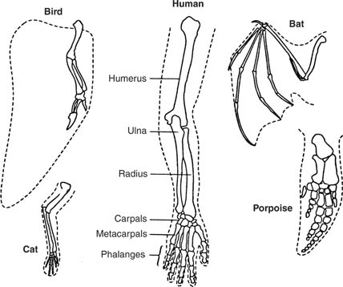

1. The diagram above is an example of:
2. Comparative embryology showing that some organisms have undergone natural selection.
3. Comparative anatomy showing that some organisms are adapted to different environments.
4. Comparative anatomy showing that some organisms share a common evolutionary ancestor.
5. How bats and birds are more closely related than Bats and humans.
6. Which of the following was not available to Charles Darwin as evidence of Natural Selection?
7. Fossil evidence.
8. Protein structure.
9. Comparative anatomy.
10. Both B and C.

Short answer Section

1. Write DEFINITIONS for the following terms.
2. Allele frequency.

_________________________________________________________________________________________________________________________________________________________________________________________________________________________________________

(2 marks)

1. Random genetic drift.

_________________________________________________________________________________________________________________________________________________________________________________________________________________________________________

(2 marks)

1. The peppered moth (*Biston betularia*) is a species of moth, found in the United Kingdom.

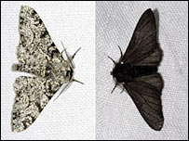

It can be found with dark or light peppered wing colouring(morphology). Below is a graph showing the frequency of the black Morphology over time.

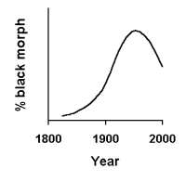

The peak in the allele frequency for black morphology occurs just before the “Clean Air Act” was passed in 1958. This act reduced the amount of smoke pollution in the United Kingdom.

Using the correct terms explain this change in allele frequency. (4 marks)

____________________________________________________________________________________________________________________________________________________________________________________________________________________________________________________________________________________________________________________________________________________________________________________________________________________________________________________________________________________________________________________________________________________________________________________________________________________________________________________________________________________________________________________________________________________________________________________________________________

1. Why do chromosome mutations cause more genetic change than single gene mutation?

(2 marks)

_________________________________________________________________________________________________________________________________________________________________________________________________________________________________________.

1. Use the diagram below to answer question 4.

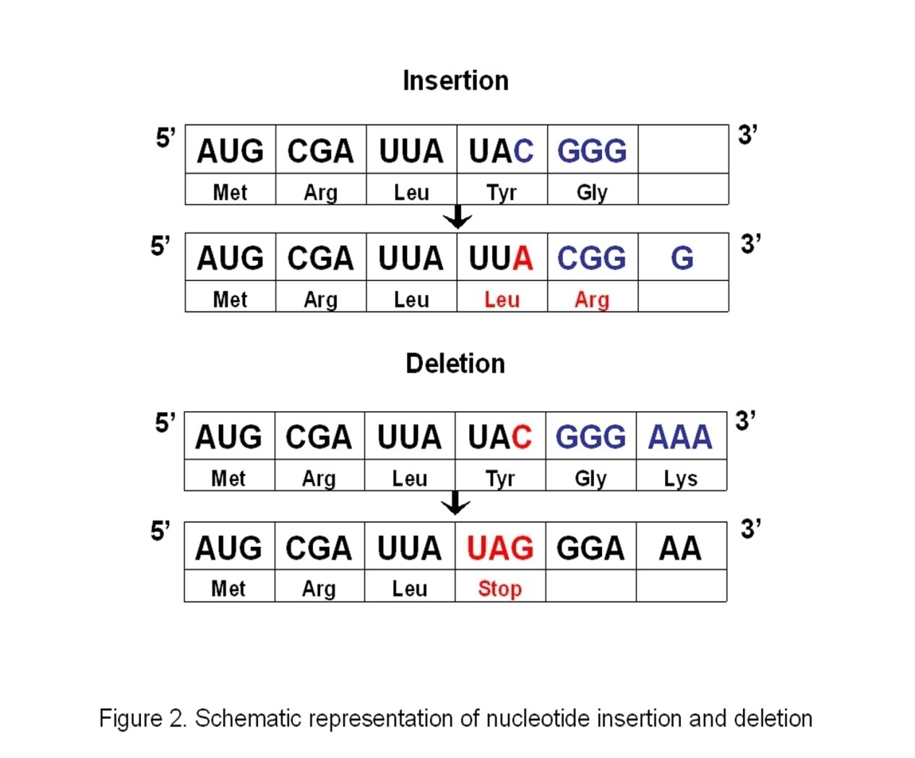

The diagrams above show two types of mutation. Name each and explain what is happening. (4 marks)

A._______________________________________________________________________________________________________________________________________________________________________________________________________________________________________.

B._______________________________________________________________________________________________________________________________________________________________________________________________________________________________________.

1. In the Lake Maracaibo region of northwest Venezuela there is a high frequency of a severe genetically inherited degenerative disorder known as **Huntington's disease**.  Many of the inhabitants are descended from a group of Spanish settlers. The main settlement site was isolated and separated from the rest of the country for about 390 years due to its geographical location. Transportation was only possible across the lake by ferry or other marine transport.

The population of Lake Maracaibo is now about 20,000 people, but for many years after settlement the populations was small and isolated.

The disease is caused by a dominant allele

All of the Lake Maracaibo region Huntington's disease victims trace their ancestry to a woman named Maria Concepción Soto who moved into the area in the 19th century.

1. State the name of the process that could have led to the high frequency of the disease.

________________________________________________________________________________________________________________________

(1 mark)

1. Maria Concepcion Soto carried the disease into the population. How could the allele have arisen in her ancestors?

_______________________________________________________________________________________________________________________

(1 mark)

1. How was gene flow reduced in the population?

____________________________________________________________________________________________________________________________________________________________________

(1 mark)

1. Which type of mutation, germ line or somatic, will potentially increase genetic variation? Give a reason for your answer.

__________________________________________________________________________________________________________________________________________________________________________________________________________________________________________________________________________________________________________________________________________

(2 marks)

1. When studying epigenetics, researchers often study the offspring of identical twins that have been separated at birth and exposed to different environments. This may involve the study of multiple generations. Why is this?

______________________________________________________________________________________________________________________________________________________________________________________________________________________________________________________________________________________________________________________________________________________

______________________________________________________________________________________________________________________________________________________________________________________________________________________________________________________________________________________________________________________________________________________

______________________________________________________________________________________________________________________________________________________________________________________________________________________________________________________________________________________________________________________________________________________

(3 marks)